Structural Effect of Low-dimensional Carbon Nanostructures on Long-term Stability of Dye Sensitized Solar Cells

Rusoma Akilimaliª, Gurpreet Singh Selopal^{a,b *}, Mahyar Mohammadnezhadª, Ibrahima Kaª, Zhiming M. Wang,^{b, d}, Gregory P. Lopinski^{c}, Haiguang Zhao ^{e}, Federico Rosei^{a,b*}
ª Institut National de la Recherche Scientifique, Centre Énergie, Matériaux et Télécommunications, 1650 Boul. Lionel Boulet Varennes, Québec, J3X 1P7, Canada.
^{b} Institute of Fundamental and Frontier Sciences, University of Electronic Science and Technology of China, Chengdu, Sichuan 610054, P. R. China.
^{c} Metrology Research Center, National Research Council Canada, 100 Sussex Dr., Ottawa, ON, K1A 0R6, Canada.
^{d}Institute for Advanced Study, Chengdu University, Chengdu, Sichuan 610106, P.R. China.
^{e} State Key Laboratory of Bio-Fibers and Eco-Textiles, Qingdao University, No. 308 Ningxia Road, Qingdao 266071, P. R. China.
Email: gurpreet.selopal@inrs.ca; federico.rosei@inrs.ca

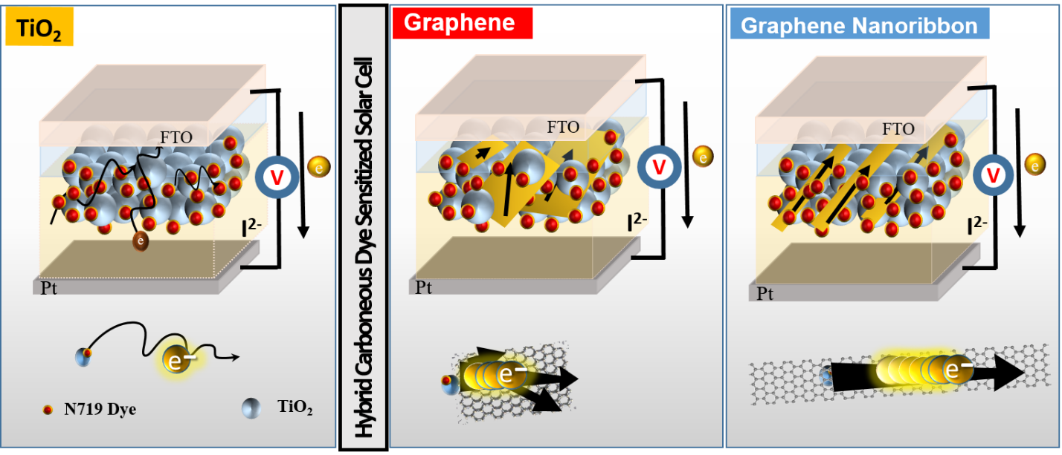
Figure 1S. Schematic of DSSCs components with TiO₂, FLG-TiO₂ and GNR-TiO₂ hybrid photoanodes highlighting preferred electrons transport through FLG and GNR within mesoporous film toward FTO.

Table 1S. Structural parameters of as received GNR and FLG.
Parameters | No. of Atomic Layers (n) | Width (d) | Length (l)
GNRs | 1 | 100-180 nm | 2-15 μm
FLG | 5-7 | 200-250 nm | 2-6 μm

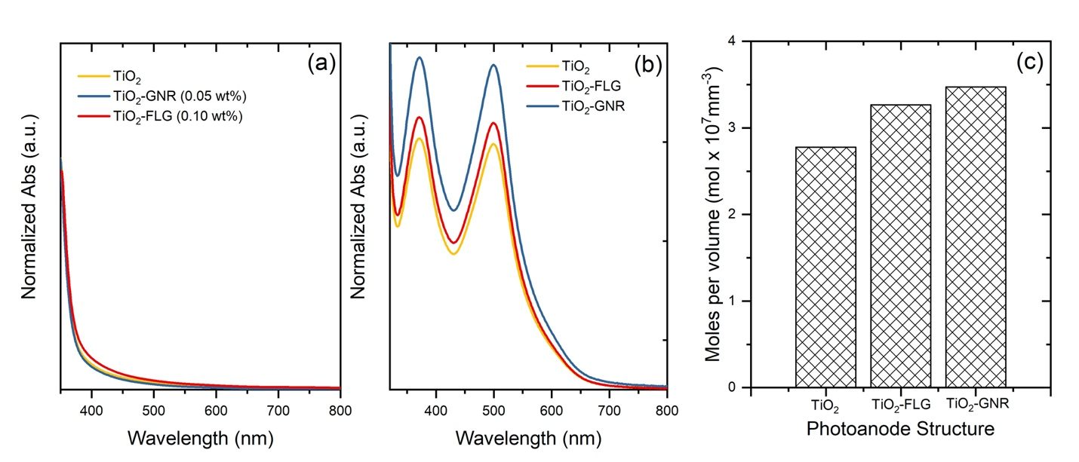
Figure 2S (a) UV-Vis absorption of TiO₂, TiO₂ with FLG and GNR hybrid photoanodes. (b) Absorption spectra of dye removal solution. (c) Dye loading vs photoanode structure.

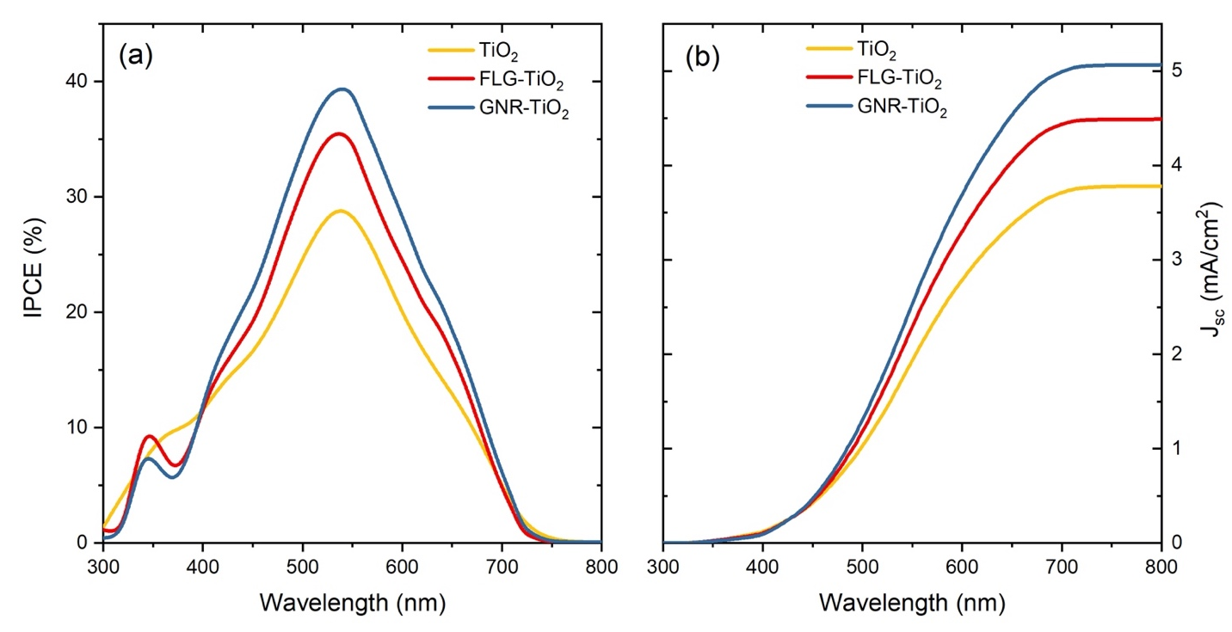
Figure 3S (a) IPCE curve for DSSCs device based on TiO₂, TiO₂ with FLG and GNR hybrid photoanodes; (b) Integrated J_{sc} curves obtained from IPCE curves for the corresponding devices.

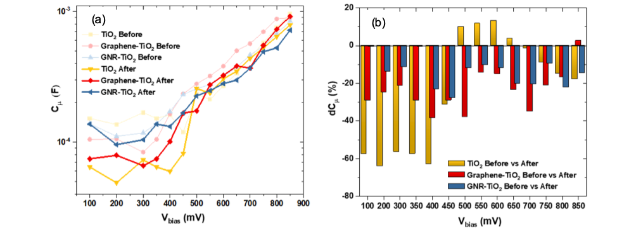
Figure 4S. Electrochemical impedance spectroscopy (EIS) analysis of DSSCs based on TiO₂, Graphene-TiO₂ and GNR-TiO₂ hybrid photoanodes before (lighter color) and after 270h (darker colours) simulated sun exposure under dark measurement: (a) chemical capacitance Cμ; (b) chemical capacitance variations dCμ

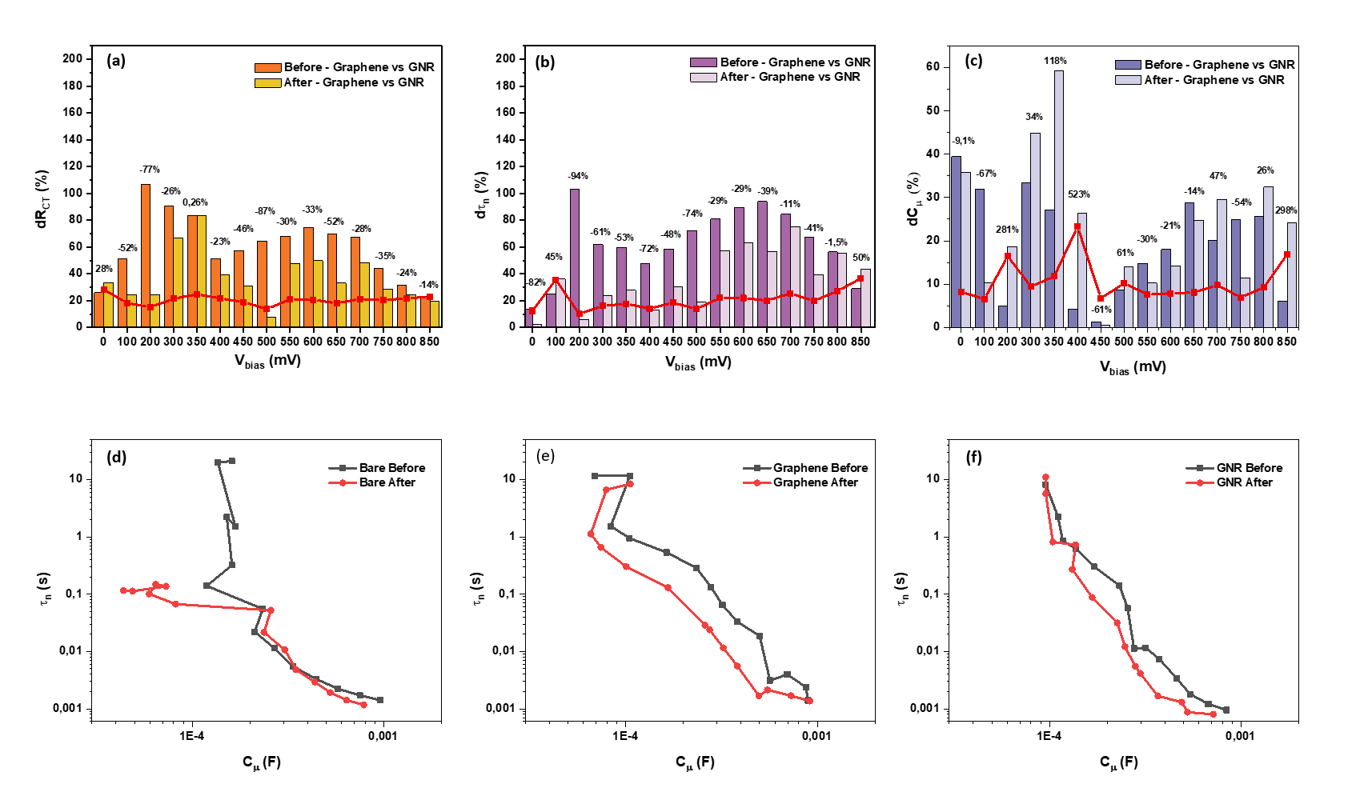
Figure 5S. Histograms of evolution of the percentage change between Graphene and GNR, before and after light soaking for R_{ct} (a), τ_{n} (b) and C_{μ} (c). Evolution of τ_{n} as of C_{μ} before and after light soaking for Bare sample (d), Graphene (e) and GNR based sample (f)

