 | mAb clone ID | Coating antigen (ELISA)
 | mAb clone ID | VHH 1 | VHH2 | VHH3 | hIgG1 antibody
1 | F233-2A3-1 | 1.857 | 1.450 | 2.290 | 0.014
2 | F233-2D2-1 | 1.660 | 1.776 | 2.018 | 0.038
3 | F233-2D5-1 | 1.420 | 1.329 | 1.614 | 0.012
4 | F233-2E10-1 | 1.735 | 1.683 | 2.260 | 0.028
5 | F233-2G2-1 | 1.337 | 1.293 | 1.617 | 0.011
6 | F233-3F12-1 | 1.900 | 2.024 | 2.595 | 0.042
7 | F233-3G11-1 | 1.730 | 2.080 | 2.359 | 0.040
8 | F233-3H12-1 | 1.736 | 1.762 | 2.314 | 0.012
9 | F236-2A4-1 | 0.147 | 1.789 | 1.339 | 0.022
10 | F236-3C7-1 | 0.090 | 2.199 | 2.263 | 0.024
11 | F236-3A8-1 | 1.680 | 1.668 | 1.860 | 0.021
12 | F236-3E5-1 | 0.150 | 1.935 | 2.020 | 0.016
13 | F236-4B2-1 | 1.072 | 1.916 | 1.935 | 0.023
14 | F236-4E1-1 | 0.191 | 1.873 | 1.947 | 0.023
15 | F258-1B2-1 | 1.978 | 0.139 | 0.025 | 0.009
16 | F258-1C5-1 | 2.202 | 0.919 | 0.486 | 0.190
17 | F258-1H5-1 | 1.129 | 0.045 | 1.816 | 0.005
18 | F258-2A11-1 | 1.398 | 1.090 | 0.032 | 0.012
19 | F258-2B10-1 | 1.108 | 0.021 | 1.752 | 0.005
20 | F258-2C9-1 | 1.543 | 1.258 | 0.008 | 0.004
21 | F258-2E8-1 | 0.037 | 1.675 | 0.037 | 0.008
22 | F258-4B2-1 | 2.346 | 2.385 | 0.336 | 0.178
23 | F258-4B5-1 | 2.195 | 1.125 | 0.513 | 0.291
24 | F258-4B9-1 | 1.728 | 1.961 | 0.109 | 0.048
25 | F258-4B10-1 | 1.459 | 0.058 | 1.427 | 0.015
26 | F258-4C7-1 | 1.674 | 0.416 | 1.915 | 0.027
27 | F258-4D9-1 | 1.493 | 0.997 | 0.013 | 0.002
28 | F258-4E4-1 | 0.075 | 0.257 | 0.101 | -0.001
29 | F258-4E5-1 | 1.356 | 0.047 | 1.367 | 0.005
30 | F258-4E11-1 | 1.202 | 0.030 | 1.346 | 0.003
31 | F258-4F6-1 | 1.459 | 0.319 | 2.127 | 0.010
32 | F258-4H10-1 | 1.575 | 0.860 | 1.603 | 0.210
33 | F258-5E1-1 | 0.023 | 1.734 | 0.045 | 0.015
34 | F258-5G8-1 | 1.152 | 1.261 | 0.003 | 0.008
35 | F258-6B10-1 | 1.525 | 0.732 | 1.542 | 0.155
36 | F258-6D10-1 | 0.678 | 0.547 | 1.170 | 0.327
37 | F258-6E2-1 | 1.660 | 0.196 | 0.049 | 0.028
anti-GFP | 3E6-2 | 0.069 | 0.031 | 0.027 | 0.023
anti-VHH3 | F236-3F7-2 | 0.217 | 0.108 | 2.383 | 0.064
anti-hIgG1 Ab | F386-1E8-1 | 0.011 | 0.009 | 0.006 | 2.315

Supplemental Table 1: ELISA results for screening of mouse anti-VHH hybridoma supernatants for VHH-reactivity and human-IgG reactivity. Hybridoma supernatants generated as described in Figure 1 were tested against surface absorbed VHHs (column 3-5) or total human IgG protein (column 6) for reactivity. Hybridoma supernatants were reacted with test antigens followed by washing and detecting with anti-mouse secondary antibodies. Results were used to select anti-VHH mAb candidates screened for reactivity to VHH-CAR cells as described in Figure 1.

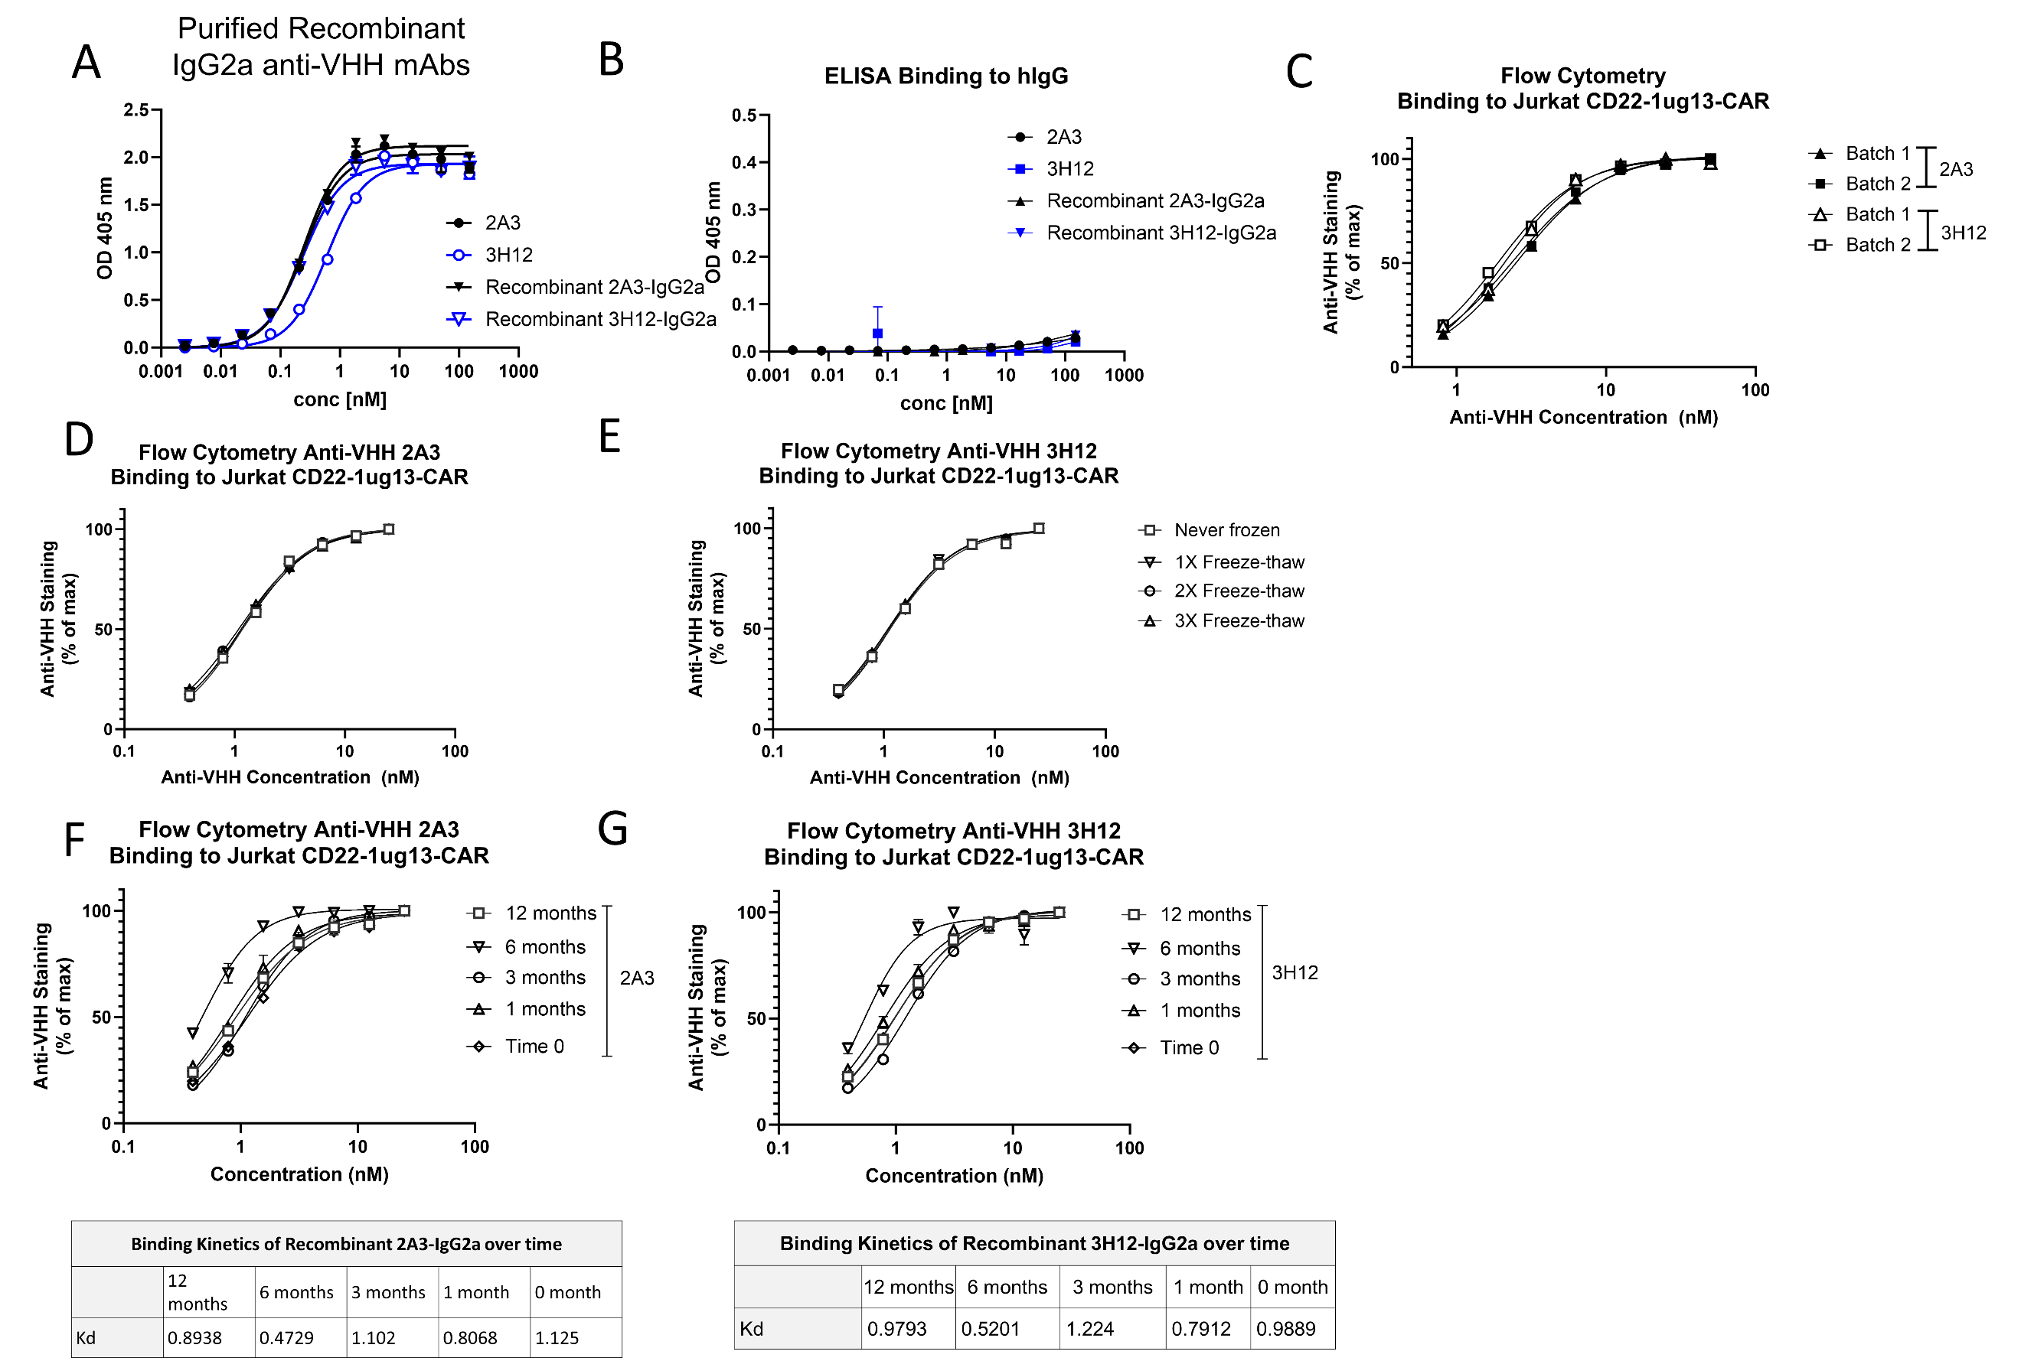

Supplemental Figure 1: Recombinant anti-VHH IgG2a mAbs maintain low reactivity to human IgG. Purified anti-VHH IgG1 2A3 or 3H12 mAbs, or the corresponding recombinant IgG2a antibodies were tested for reactivity via (A) an ELISA performed against purified VHH using purified IgG1 anti-VHH mAbs or recombinant IgG2a anti-VHH mAbs (rec2A3 and rec3H12). (B) Total human IgG protein using anti-mouse IgG as a detection antibody. Results demonstrate that purified anti-VHH mAbs maintain high reactivity to llama VHH with low reactivity to human antibodies. Anti-VHH mAbs were then examined for production consistency using (C) assessment of binding to VHH-CAR via flow cytometry over a range of anti-VHH mAb concentration. (D-E) Stability of anti-VHH mAbs over multiple rounds of freeze-thaw was also confirmed via flow cytometry over a range of anti-VHH mAb concentrations. (F-G) Aliquots of anti-VHH mAbs were stored at -80°C and examined for reactivity to VHH-CAR expressing cells at various timepoints after freezing via titrated flow cytometry, confirming product stability for at least 12 months.

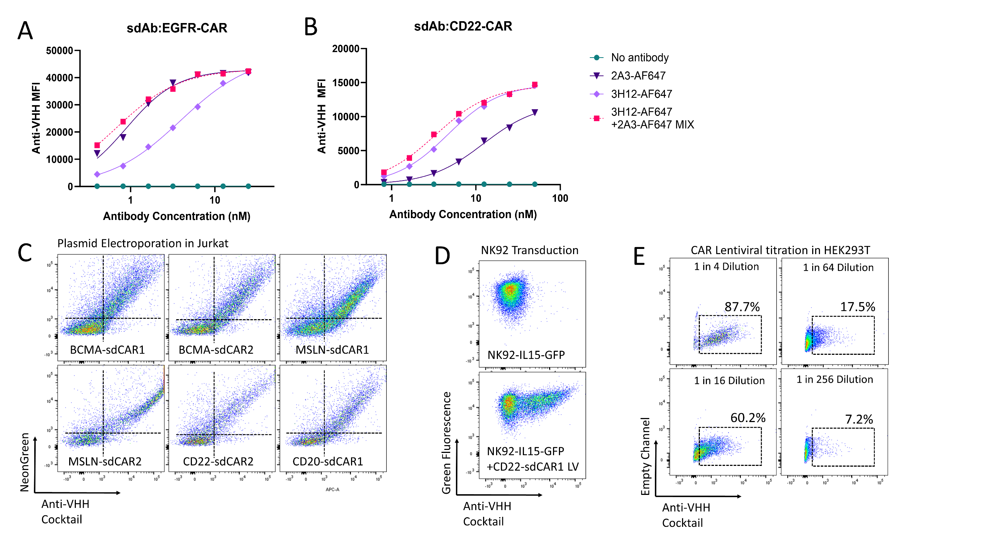
Supplemental Figure 2: A mixed antibody product of recombinant anti-VHH mAbs can be applied to quantitate surface VHH-CAR expression. The heavy and light chain variable genes were sequenced from selected 2A3 and 3H12 hybridoma clones. The variable domains from these clones were then fused to mouse IgG2a backbones to improve productivity and stability of purified antibodies. Recombinant anti-VHH mAbs were directly labelled with AlexaFluor-647 and used individually or as a 1:1 molar ratio mix of both antibodies. VHH-CAR Jurkat cells known to have (A) lower affinity for either 3H12 (EGFR-CAR), or (B) lower affinity for 2A3 (CD22-CAR) were stained and examined via flow cytometry. (C) VHH-CAR expressing cells were generated expressing 6 divergent CARs, stained with the AF647 anti-VHH mAb cocktail and assessed via flow cytometry. (D) Similarly, VHH-CAR expression on stable IL15-GFP expressing natural killer (NK92-IL15) cells was also confirmed using anti-VHH mAb staining. (E) HEK293 cells were used to titrate non-fluorescently labelled VHH-CAR lentiviral particles by using varying dilutions of viral supernatant on HEK cells via AF647 anti-VHH mAb staining and flow cytometry.

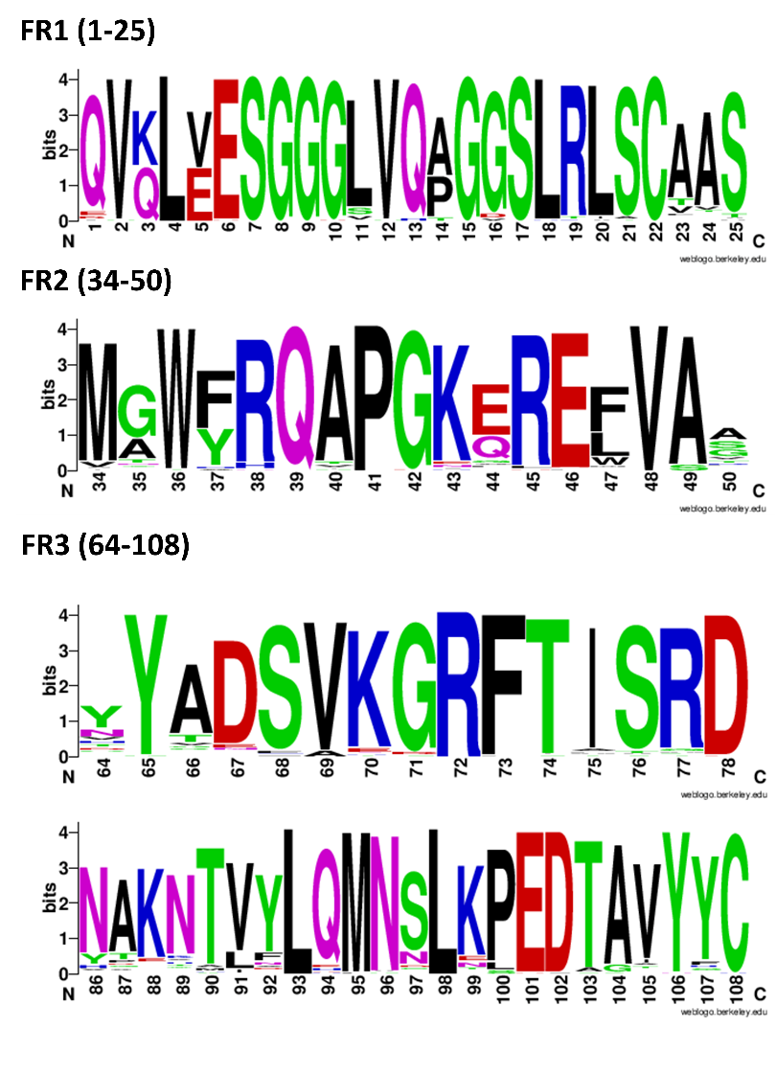
Supplemental Figure 3: Framework regions 1-3 sequences from 76 Lama glama VHH sequences. VHH sequences available in our laboratory inventory (unpublished) were aligned using Clustal Omega v1.2.1 (1) and analyzed using Weblogo (2). The colors for each amino acid group indicates their chemical properties and the sequences logo shows the relative conservation of each amino acid in each position. Polar amino acids (G,S,T,Y,C,Q,N) are green, basic (K,R,H) blue, acidic (D,E) red and hydrophobic (A,V,L,I,P,W,F,M) amino acids are black. The residue numbering does not accurately follow the known IMGT VHH numbering system and is generated for the purpose of alignment.

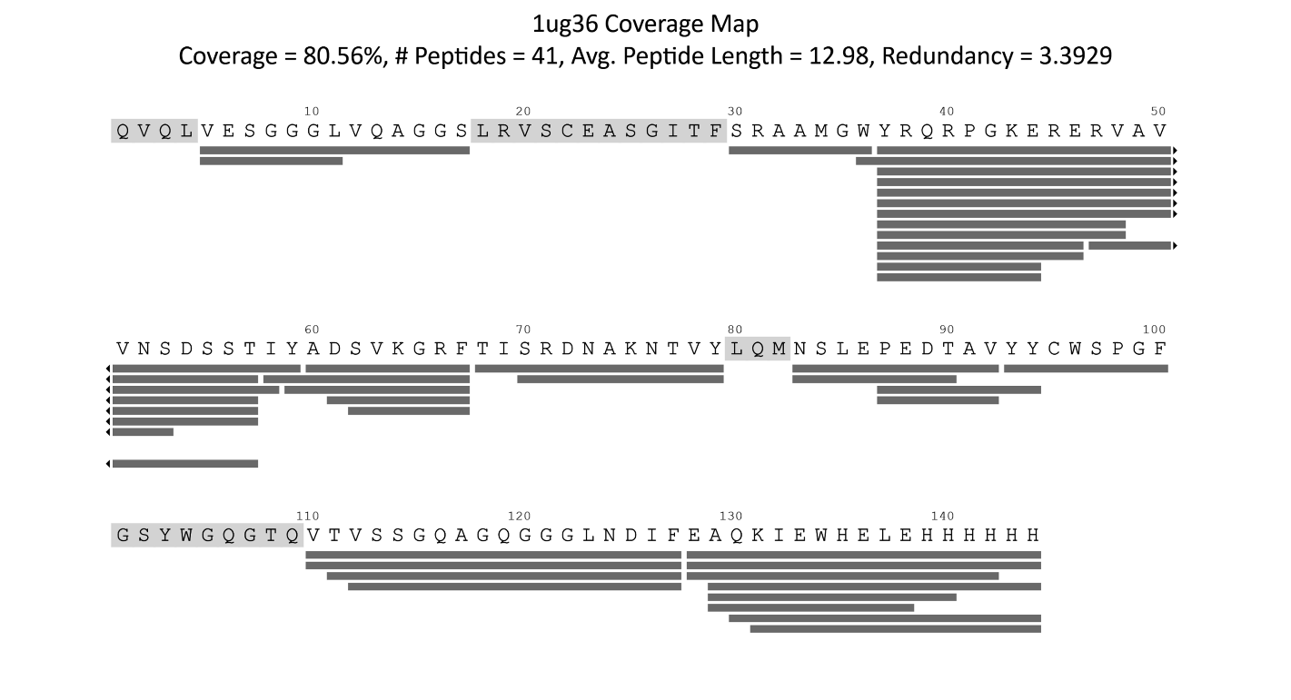
Supplemental Figure 4. HDX-MS sequence coverage. Deuterated peptides are shown as grey rectangles below the amino acid sequence. Coverage map generated with MS Studio (3).

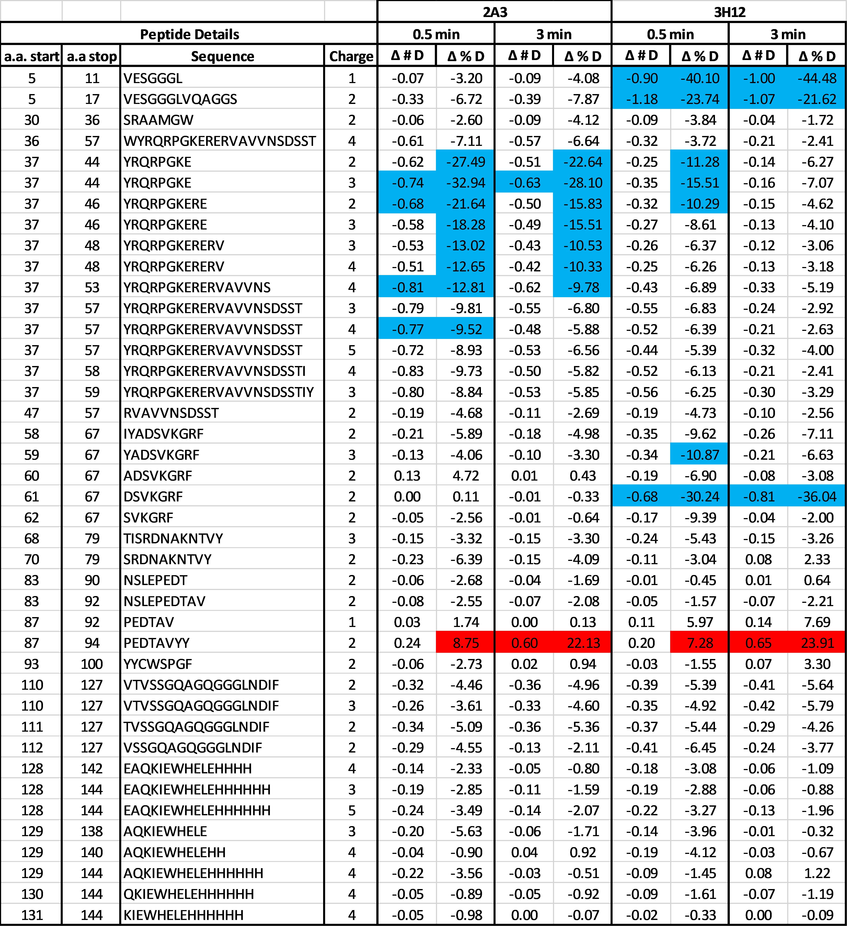
Supplemental Table 2. Relative deuteration for VHH detected peptides via HDX-MS. Absolute (# D) and Normalized (% D) Differential HDX-MS for each identified peptide (n = 3). Significant reductions and increases in HDX in the bound state relative to the unbound state are shown in blue and red, respectively.
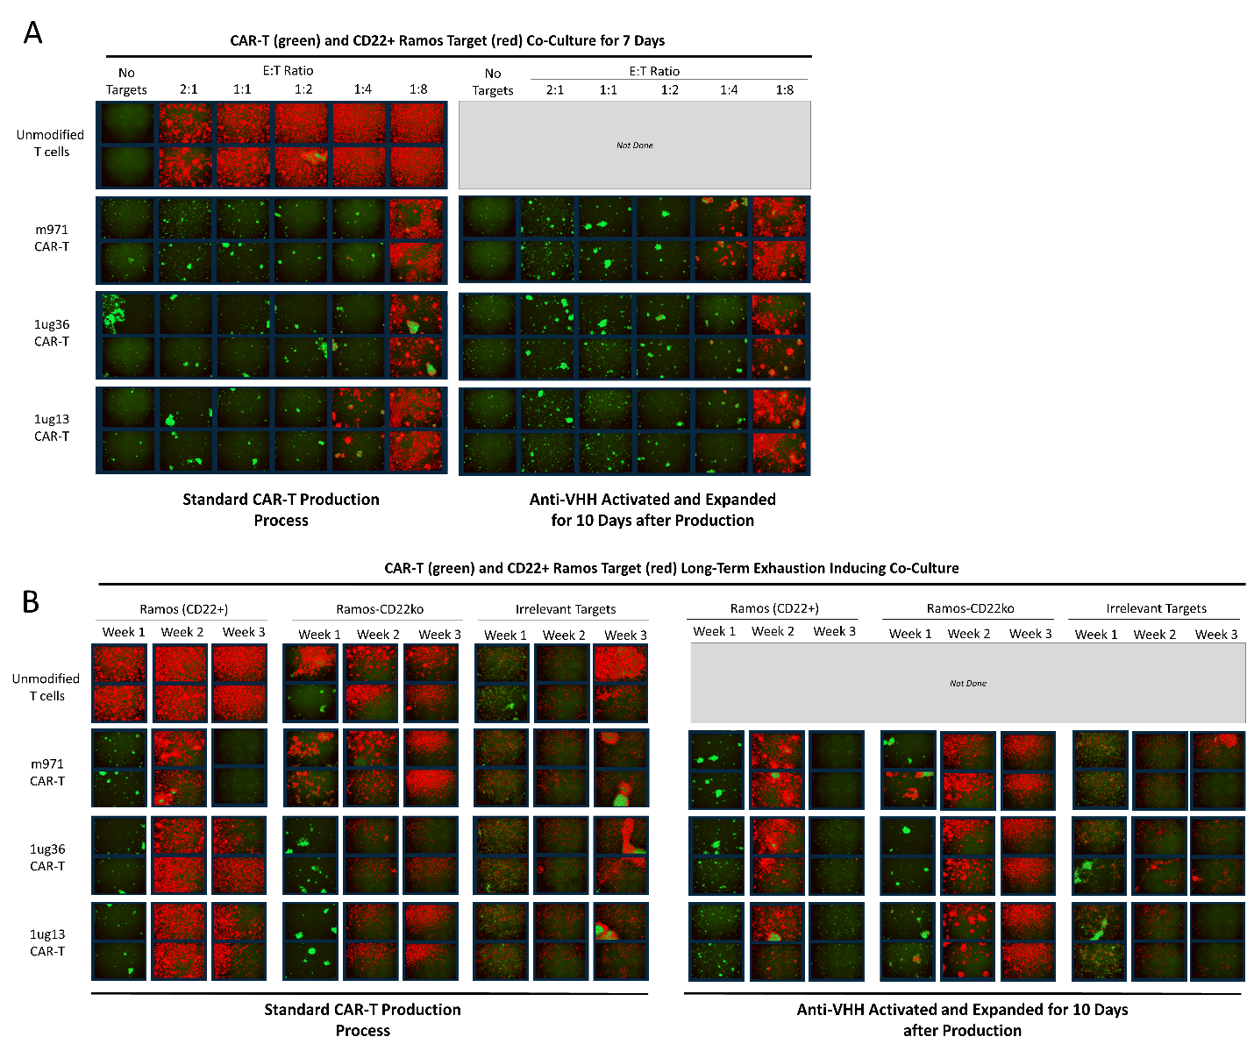
Supplemental Figure 5: Fluorescence images demonstrate short and long-term function of CD22 CAR-T cells with or without anti-VHH mAb stimulation. Cryopreserved CD22 CAR-T cells or matched untransduced T cells were activated with anti-VHH mAb coated plates, or left non-activated, and expanded for 12 days. CAR-T cells with or without activation were then placed in co-culture with red-fluorescent protein expressing target cells. (A) Co-cultures of 20 000 target cells were established with varying numbers of CAR-T cells to achieve effector to target ratios. Images show the relative number of CAR-T cells (green) and target cells (red) after 7 days of co-culture. (B) Similarly, co-cultures were monitored in a longer term exhaustion inducing assay, wherein additional targets were added twice per week, and cultures were split 1 in 5 once per week. Images show the relative number of CAR-T cells (green) and target cells (red) before cell culture splits at days 7, 14, and 23 of co-culture.

References for supplemental material
1. Sievers,F. and Higgins,D.G. (2018) Clustal Omega for making accurate alignments of many protein sequences. Protein Sci, 27, 135–145.
2. Crooks,G.E., Hon,G., Chandonia,J.-M. and Brenner,S.E. (2004) WebLogo: a sequence logo generator. Genome Res, 14, 1188–1190.
3. Rey,M., Sarpe,V., Burns,K.M., Buse,J., Baker,C.A.H., van Dijk,M., Wordeman,L., Bonvin,A.M.J.J. and Schriemer,D.C. (2014) Mass spec studio for integrative structural biology. Structure, 22, 1538–1548.

