Electronic Supporting Information

Figure S1. Optical transmittance spectrum of the rra-P3HT:BNNT-coated PET and PVB:BNNT-coated PET with bare PET acting as the background filter

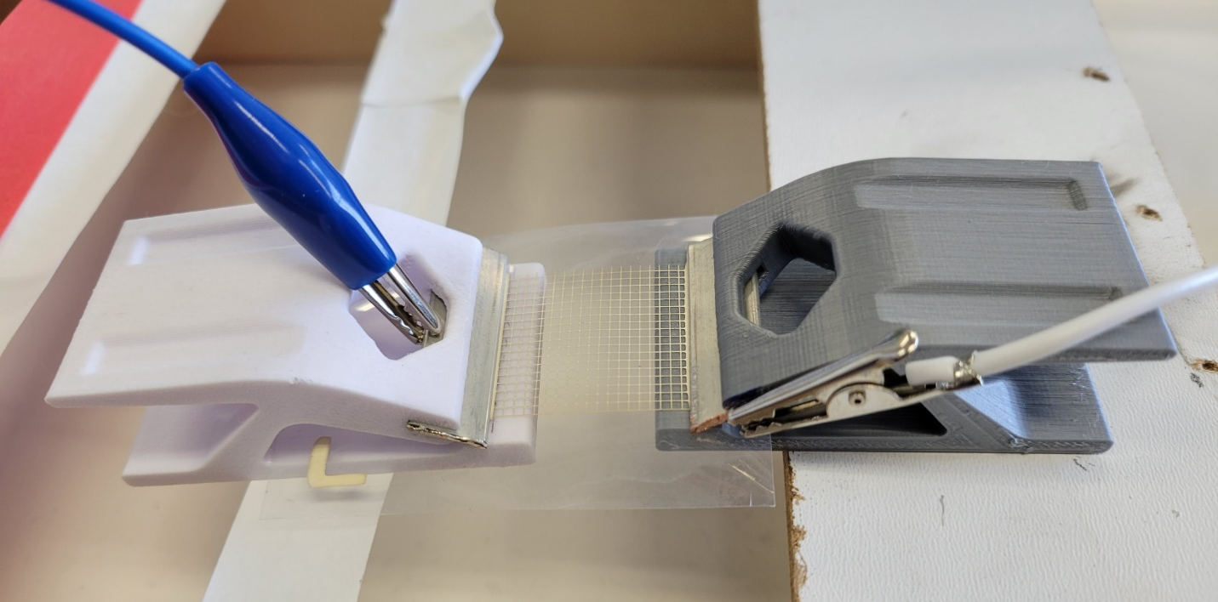
Figure S2. Thermal cycling test set-up with 3D-printed clips to secure copper tape onto electrical measuring pads of 50/1300 silver microgrid printed on PVB:BNNT-coated PET

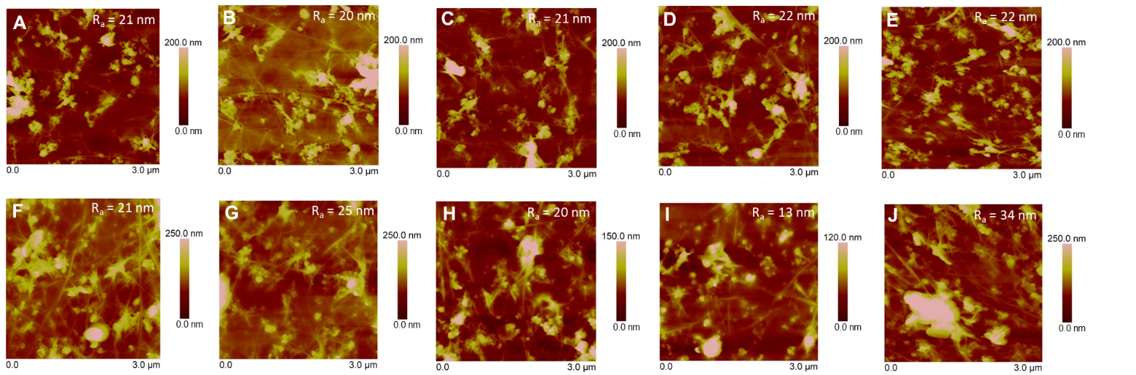
Figure S3. Atomic force microscopy height images of A-E) rra-P3HT:BNNT-coated PET and F-J) 8-layer PVB:BNNT-coated PET with a scanned area of 3.0 µm²

Figure S4. Graphical summary of measured average surface roughness (R_{a}) and RMS roughness (R_{q}) taken from atomic force microscopy (AFM) measurements of rra-P3HT:BNNT films (n = 20) and PVB:BNNT films (n = 20) with a measuring area of 3.0 µm²

Table S1. Statistical data of atomic force microscopy measurements of average surface roughness (R_{a}) and RMS roughness (R_{q}) of rra-P3HT:BNNT-coated PET and PVB:BNNT-coated PET with a measuring area of 3.0 µm²

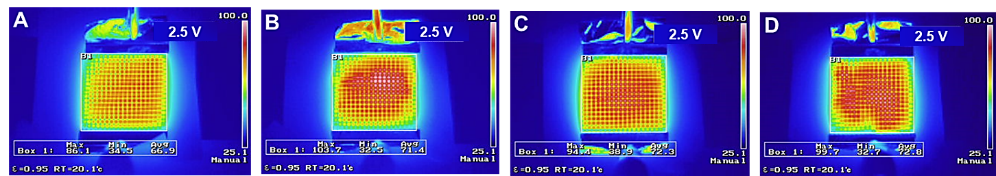
Figure S5. Infrared (IR) thermal imaging taken at t = 160 s of a 50/1300 Ag microgrid printed on A) bare PET, B) 4-layer, c) 8-layer and d) 12-layers of PVB:BNNT coatings on PET

Figure S6. Infrared (IR) thermal imaging taken at t = 160 s of a 50/1300 Ag microgrid printed on PVB-coated PET subjected to applied A) 1.0 V, B) 1.5 V, C) 2.0 V, and D) 2.5 V

Figure S7. Infrared (IR) thermal imaging taken at t = 160 s of a 50/1300 Ag microgrid printed on rra-P3HT:BNNT-coated PET subjected to applied A) 1.0 V, B) 1.5 V, C) 2.0 V, and D) 2.5 V

Figure S8. Infrared (IR) thermal imaging taken at t = 160 s of a 50/1300 Ag microgrid printed on PVB:BNNT-coated PET subjected to applied A) 1.0 V, B) 1.5 V, C) 2.0 V, and D) 2.5 V

